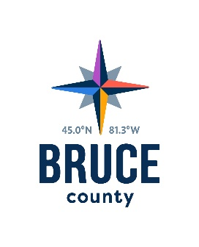Human Resources Committee Minutes

November 1, 2018

10:33 a.m.

Council Chambers, Bruce County Administration Centre
Walkerton, Ontario

Present: Warden Paul Eagleson (Chair)
Councillors Robert Buckle, David Inglis, Janice Jackson, Milt McIver, Mike Smith and Mitch Twolan

Staff: Kelley Coulter, Chief Administrative Officer
Darlene Batte, Deputy Clerk
Marianne Nero, Director of Human Resources
Donna Van Wyck, Clerk

Regrets: Councillor Anne Eadie

Pecuniary Interest
There were no declarations of pecuniary interest.

Closed Meeting
Moved by Councillor David Inglis
Seconded by Councillor Robert Buckle

That the Committee move into a closed meeting pursuant to:
- Section 239 (2) (b) of the Municipal Act, 2001, to discuss personal matters about an identifiable individual, including municipal or local board employees; and,

- Section 239 (3.1) of the Municipal Act 2001, for the purpose of educating or training members.
Carried

Rise and Report

Moved by Councillor David Inglis

Seconded by Councillor Janice Jackson

That the Committee rise and report from the closed meeting.

Carried

The Chair reported that staff were provided direction during the closed meeting.

Cathy McGirr, Kara Van Myall, Nicole Charles, Michael McKeage joined the meeting at 11:01 a.m.

Act on Recommendations
Moved by Councillor Mitch Twolan
Seconded by Councillor David Inglis

That in accordance with the Procedure By-law, staff be authorized and directed to give effect to the actions of the Human Resources Committee in respect of all resolutions passed during the November 1, 2018 meeting.

Carried

Next Meeting
The next meeting of the Human Resources Committee will take place on
November 15, 2018 in the Council Chambers, County Administration Centre, Walkerton, Ontario.

Adjournment

Moved by Councillor Robert Buckle

Seconded by Councillor Mike Smith

That the meeting of the Human Resources Committee adjourn at
11:03 a.m.

Carried

Warden Paul Eagleson, Chair
Human Resources Committee

