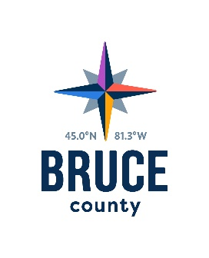
  - Corporate Services Committee Minutes

November 15, 2018
12:52 p.m.

Council Chambers, Bruce County Administration Centre

Walkerton, Ontario

Present: Councillors David Inglis, (Acting Chair), Robert Buckle, Anne Eadie, Janice Jackson, Mike Smith and Milt McIver
Alternate Councillor Wilf Gamble

Staff: Marianne Nero, Acting Chief Administrative Officer
Darlene Batte, Deputy Clerk
Bettyanne Cobean, Director of Corporate Services
Donna Van Wyck, Clerk

Regrets: Warden Paul Eagleson, Councillor Mitch Twolan, Kelley Coulter, Chief Administrative Officer

Pecuniary Interest
There were no declarations of pecuniary interest.

Action Items
- 2019 Annual Business Plan and Budget Timetable
Moved by Councillor Mike Smith
Seconded by Councillor Milt McIver

That the 2019 Budget and Annual Business Plan Timetable report be approved; and,

That January 10th and 11th,2019 be reserved to receive the 2019 Annual Business Plans and Operational and Capital Budgets, and January 24th, 2019 be reserved for follow up discussions.

Carried

Councillor Anne Eadie joined the meeting at 12:54 p.m.

Information Items
The 2018 Annual Business Plan and Financial Position Update report was received for information.

Act on Recommendations
Moved by Councillor Robert Buckle
Seconded by Councillor Mike Smith

That in accordance with the Procedure By-law, staff be authorized and directed to give effect to the actions of the Corporate Services Committee in respect of all resolutions passed during the November 15, 2018 meeting.

Carried

Next Meeting
The next meeting of the Corporate Services Committee will take place on December 6, 2018 in the Council Chambers, County Administration Centre, Walkerton, Ontario.

Adjournment
Moved by Councillor Anne Eadie
Seconded by Councillor Mike Smith

That the meeting of the Corporate Services Committee adjourn at
12:59 p.m.

Carried

Councillor David Inglis, Acting Chair
Corporate Services Committee

